# Grupa 2.

IfStatement → if ( RelExpression ) :

Expression ElsePart   
ElsePart → else : Expression

RelExpression → Term > Term | Term   
Expression → Expression * Term | Term   
Term → ID | CONST

I → if( RE): E EP

RE→ T>T

RE→ T

E→ E * T

E→ T

EP→ else : E

T → ID

T→ CONST

1.

*l* 0:

*I’* → . *I*

*I* → . if( *RE*): *E EP*

*RE*→ .*T*>*T*

*RE*→ .*T*

*E*→ .*E* * *T*

*E*→ .*T*

*EP*→ .else : *E*

*T* → .ID

*T*→ .CONST

*l* 1=goto(*l* 0, *I*)

*I’*=*I*.

*l* 2=goto(*l* 0, if)

*I’* → *I*.

*I* → if.( *RE*): *E EP*

*l* 3=goto(*l* 2, ( )

*I* → if( .*RE*): *E* *EP*

*RE* → .*T*>*T*

*RE*→ .*T*

*E*→. *E* * *T*

*E*→ .*T*

*EP*→ .else : *E*

*T* → .ID

*T*→ .CONST

*l* 4=goto(*l* 3, *T*)

*RE* → *T*. >*T*

*RE* → *T*. Redukciono stanje za smenu 3

*T* → ID .

*T*→ CONST.

*l* 5=goto(*l* 4, >)

*RE* → *T*> . *T*

*T* → .ID

*T*→ .CONST

*l* 6=goto(*l* 5, *T*)

*RE* → *T*> *T* . Redukciono stanje za smenu 2

*l* 7=goto(*l* 3, ID) *l* 7=goto(*l* 5, ID) *l* 7=goto(*l* 10, ID) *l* 7=goto(*l* 12, ID) ) *l* 7=goto(*l* 16, ID) ) *l* 7=goto(*l* 18, ID)

*T* → ID. Redukciono stanje za smenu 7

*l* 8=goto(*l* 3, CONST) *l* 8=goto(*l* 5 , CONST) L8=goto(L10, CONST) L8=goto(L12, CONST) *l*8=goto(*l* 16, CONST) *l* 8=goto(*l* 18, CONST)

*T*→ CONST . Redukciono stanje za smenu 8

*l* 9=goto(*l* 4, ) ) *l* 9=goto(*l*6, ) )

*I* → if( *RE* ). : *E* *EP*

*l* 10=goto(*l* 9 , : )

*I* → if( *RE* ): . *E* *EP*

*E*→. *E* * *T*

*E*→ .*T*

*EP*→ .else : *E*

*T* → .ID

*T*→ .CONST

*l* 11=goto(*l* 10 , *E*)

*E*→ *E* . * *T*

*l* 12=goto(*l* 11 , * )

*E*→ *E* * . *T*

*T* → .ID

*T*→ .CONST

*l* 13=goto(*l* 12, *T*)

*E*→ *E* * *T*. Redukciono stanje za smenu 4

*l* 14=goto(*l* 10, *T*)

*E*→ *T* . Redukciono stanje za smenu 5

*l* 15=goto(*l* 13, else) *l* 15=goto(*l* 14, else)

*I* → if( *RE* ): *E* *else. : E*

*EP*→else . : *E*

*E*→. *E* * *T*

*E*→ .*T*

*T* → .ID

*T*→ .CONST

*l* 16=goto(*l* 15, : )

*I* → if( *RE* ): *E* *else : . E*

*EP*→else : . E

*E*→. *E* * *T*

*E*→ .*T*

*T* → .ID

*T*→ .CONST

*l* 17=goto(*l* 16 , *E*)

*E*→ *E* . * *T*

*l* 18=goto(*l* 17, * )

*E*→ *E* * . *T*

*T* → .ID

*T*→ .CONST

*l* 19=goto(*l* 18, T)

*E*→ *E* * *T*. Redukciono stanje za smenu 4

*I* → if( *RE*): *E* *EP* . Redukciono stanje za smenu 6

Redukciono stanje za smenu 1

*l* 20=goto(*l* 16, T)

*E*→ *T* . Redukciono stanje za smenu 5

*I* → if( *RE*): *E* *EP* . Redukciono stanje za smenu 6

Redukciono stanje za smenu 1

2.

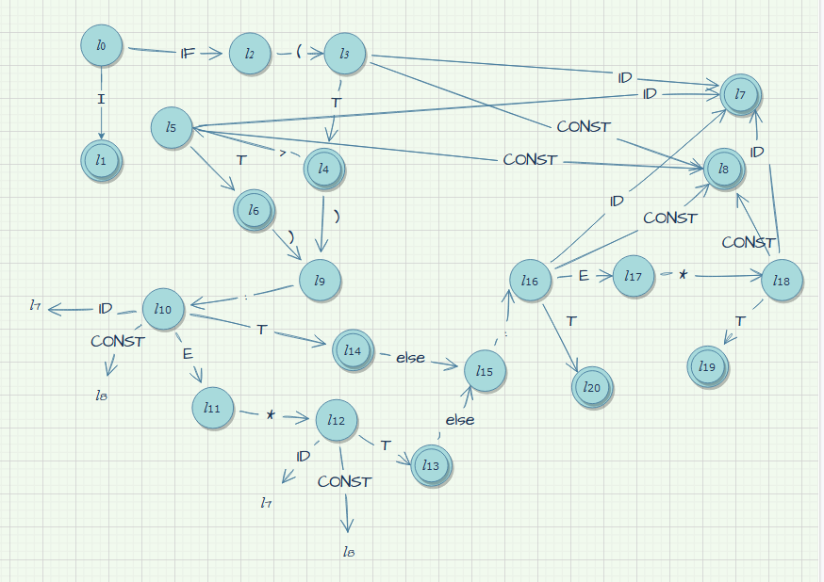

3.

Pomoćna tabela Follow(A) i First(alpha) funkcija za konkretne smene

|  |  |  |  |  |
| --- | --- | --- | --- | --- |
| Redni broj smene | Redukciono stanje | A $→$ alpha | FOLLOW(A) | FIRST(alpha) |
| 0. | l1 | Ss’ Ss | **#** | **ID, repeat** |
| 1. | l3 | Ss Ss **;** S | **# ;** | **ID, repeat** |
| 2. | l4 | Ss S | **# ;** | **ID, repeat** |
| 3. | l5 | S A | **# ; }** | **ID** |
| 4. | l6 | S WS | **# ; }** | **repeat** |
| 5. | l9 | A **ID =** T | **# ; }** | **ID** |
| 6. | l11 | A **ID =** T **+** T | **# ; }** | **ID** |
| 7. | l12 | T ID | **# ; } +** | **ID** |
| 8. | l13 | T CONST | **# ; } +** | **CONST** |